Scan file that have a data of patients in the website, to ensure it is safe:-
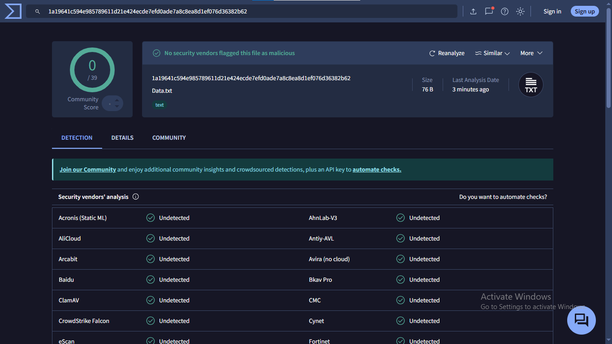
After Scanning the file is completely safe.

Encrypt file and decrypt file to make patient data safe, by using “Symmetric encryption: AES-256-CBC”.
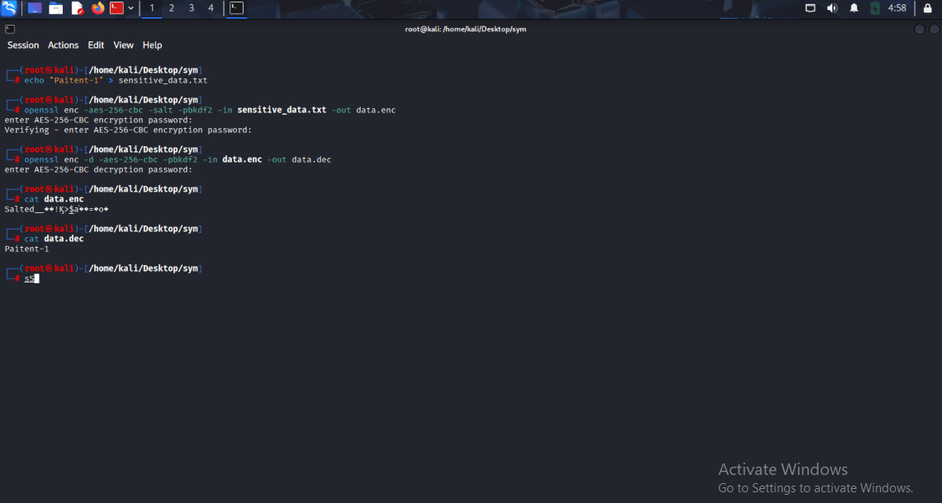
Command for encryption and decryption:-
------------------------------------------------------------------------------------------------------------------------------------------
echo "Paitent-1" > sensitive_data.txt
openssl enc -aes-256-cbc -salt -pbkdf2 -in sensitive_data.txt -out data.enc
openssl enc -d -aes-256-cbc -pbkdf2 -in data.enc -out data.dec
cat data.enc
cat data.dec
------------------------------------------------------------------------------------------------------------------------------------------
Required resources: Kali-OS, Openssl, Word.

